R-Shiny App: RNA-Seq Pipeline
Project Topic:
A function that takes raw gene count matrices from NGS experiments, runs QC checks, normalizes them, and outputs cleaned data + diagnostic plots.

About This Project:
In an RNA Sequencing Experiment, raw gene expression reads are obtained from samples (e.g., experimental and control conditions) in FASTQ format. The goal of this project is to process these raw reads through a bioinformatics pipeline, including quality control, alignment, quantification, and statistical analysis, to produce biologically relevant results such as differentially expressed genes, statistical summaries, and visualization (such as heat maps, volcano plots, etc.).
Prior to downstream statistical analysis on R, several preprocessing steps are performed in a Linux environment. These include quality check of raw reads using FASTQC, trimming of low-quality bases using the Trimmomatic tool, alignments of filtered reads to a reference genome using HISAT2 (producing SAM/BAM alignment files), and generation of a feature count matrix (using the subread tool/package) representing gene-level read counts across all samples.
This count matrix is then imported into R and processed through the pipeline I developed. The pipeline performs data quality checks, normalization, differential expression analysis, and annotation of genes, and it produces a variety of diagnostic plots such as heatmaps, volcano plots, and bar plots. The final output includes both cleaned data tables (normalized and annotated counts) and visual summaries, providing an efficient and reproducible workflow for RNA-seq data interpretation.

RECAP ON MIDTERM FUNCTIONS
- Load R-Shiny Package & Increase Upload Limit of Shiny App
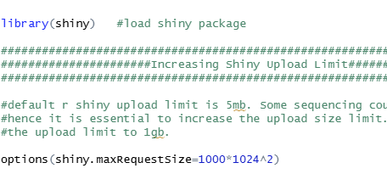
We would first load the Shiny package, and increase upload limit from the default which is 5mb to 1gb, as some count files that we need to upload could exceed the default upload limit.
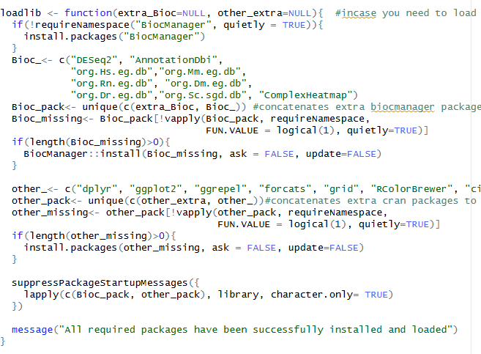
- Installing the necessary packages for the function downstream

We create an object named loadlib, in which we will install all the necessary packages required for the RNA-seq differential expression analysis pipeline.
- Reading raw CSV feature count files and metadata
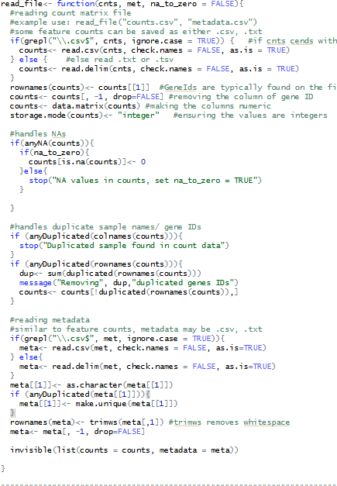
In this step, I read in the raw feature count data and the corresponding metadata files, which can be in .txt, .tsv, or .csv format. Using the grepl() function, I included a condition to check whether the file name ends with .csv so that the function knows whether to use read.csv() or read.delim() for reading the data. After loading the count data, I removed the first column containing gene IDs and set them as row names. I then converted the count values to a numeric matrix and ensured that all values were stored as integers.
Next, I handled missing values by adding the na_to_zero argument, which replaces any NA values in the count matrix with zeros if set to TRUE. If the argument is not specified, the function will stop and issue a warning about the presence of missing values. I also included checks for duplicate sample names and gene IDs to prevent errors in downstream analysis. Finally, I applied a similar approach to read the metadata file, ensuring that its structure matched the counts data. The function outputs an invisible list containing both the counts and metadata objects, which can then be used in subsequent steps of the DESeq workflow.
- Quality checks on the count matrix and metadata, and preparation of metadata for DESeq
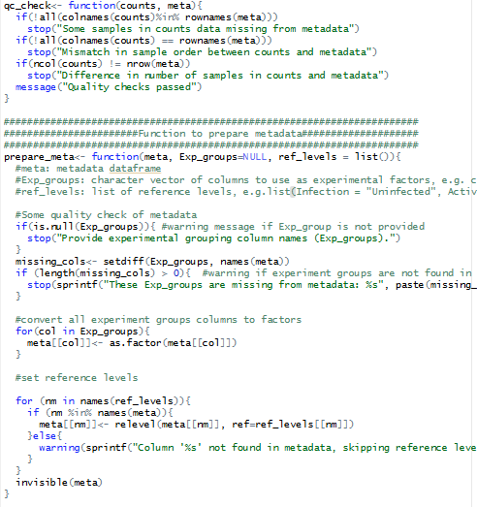
In this step, I performed quality checks on the count and metadata datasets to ensure that the column names in the count data and the row names in the metadata correspond to the same samples. This check also verifies that both datasets contain the same number of samples and that they are arranged in the same order. If any discrepancies are found, the function will stop and display an appropriate error message; otherwise, it outputs a message confirming that the quality check has passed.
Next, I prepared the metadata for downstream DESeq dataset generation. The metadata file includes information on the experimental groups (Exp_groups) and reference levels (ref_levels), which are specified as arguments. I added comments to indicate how these arguments should be entered when running the function. Because DESeq requires the experiment group columns to be factors, I used a loop to convert each column listed in Exp_groups to a factor. This approach allows the function to handle multiple columns efficiently. Finally, I set the reference levels for each factor, ensuring that the correct baseline levels are applied for comparisons in the DESeq analysis.
- Running the DESeq Analysis
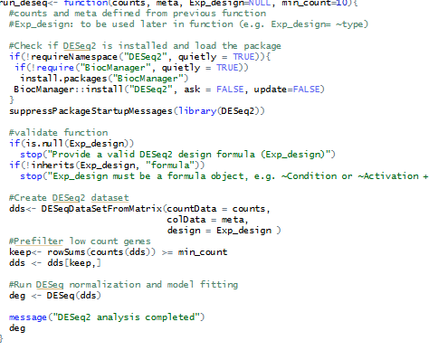
For this function, I used the count data from the readfile() function and the metadata from the prepare_meta() function as arguments. The metadata file includes the experimental design (Exp_design), which must be written directly as a formula. I included checks to ensure that necessary packages such as BiocManager and DESeq2 are installed before running the analysis. I also added a validation step to confirm that Exp_design is a valid formula; if it is missing or incorrectly specified (for example, written as Activation instead of ~Activation), the code will stop and display an error message. Once the input and design were verified, I created the DESeq2 dataset and filtered out low-count genes based on the minimum count threshold. Finally, I ran the DESeq() function to perform normalization and model fitting, which generated the DESeq dataset for downstream analysis.

- Extracting results after DESeq data is generated
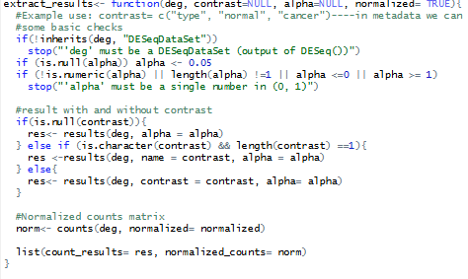

Next, I included a step to verify that the argument provided for deg is actually a DESeqDataSet object. This check ensures that the function only runs on valid input data generated from DESeq2. If the input is not of the correct type, the function stops and returns an error message, which helps prevent downstream issues. I also added a check for the alpha argument to make sure it is numeric and falls between 0 and 1. If alpha is missing, it automatically defaults to 0.05, which is a standard significance cutoff value. After confirming the inputs are valid, the function extracts results based on whether or not a contrast is specified. If no contrast is provided, the function extracts general results using the default parameters. However, if a contrast is included (for example, comparing two conditions such as “cancer” versus “normal”), the function extracts results specific to that comparison. Finally, the code retrieves the normalized counts matrix using the counts() function, which produces normalized expression values for each gene. Both the DESeq2 results and the normalized counts are then returned together as a list, allowing for easy access and further analysis.

- Annotating Gene names from geneIDs from the specified organism database
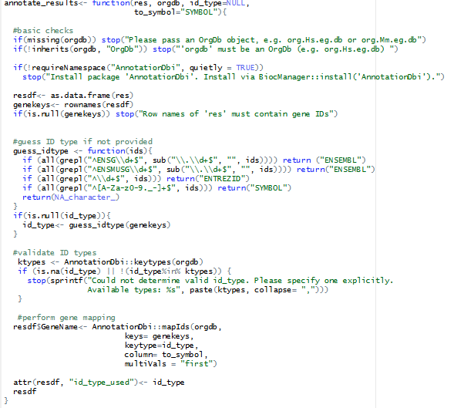
I first included basic checks to ensure that only valid orgdb objects are used. Then I verified that the necessary packages are installed and prompted the user to install them if they are not already installed. The code then extracts gene IDs from the results dataframe and validates that they exist and are correctly formatted. If the type of gene ID is not explicitly provided by the user, the function attempts to automatically guess it based on the format of the IDs (e.g., whether they follow ENSEMBL, ENTREZID, or SYMBOL patterns). Once the ID type is determined, the function validates it against the available key types in the specified organism database to ensure it is compatible for mapping. Finally, the function uses the mapIds() function from AnnotationDbi to match each gene ID with its corresponding gene symbol, returning a dataframe that includes the original results and an additional column for the annotated gene names. The ID type used for mapping is also saved as an attribute for reference. This step adds meaningful biological context to the DESeq results, making it easier to interpret the data and link the results to known genes.
- Extracting top genes
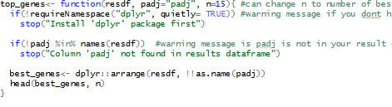
Next, I extracted the top 15 genes (this number can be adjusted by changing the n argument) from the results data frame generated in the previous function. First, I ensured that the dplyr package was installed and that the padj column (which contains the adjusted p-values) was present in the data frame. Using functions from dplyr, I arranged the dataframe in ascending order based on the adjusted p-values, so that the most statistically significant genes appear at the top. Finally, I used the head() function to extract the top genes according to the value of n, storing these in the best_genes object for further downstream analysis or visualization.
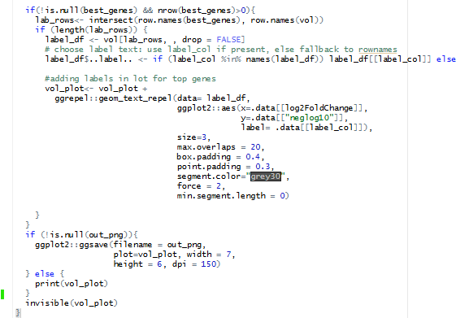
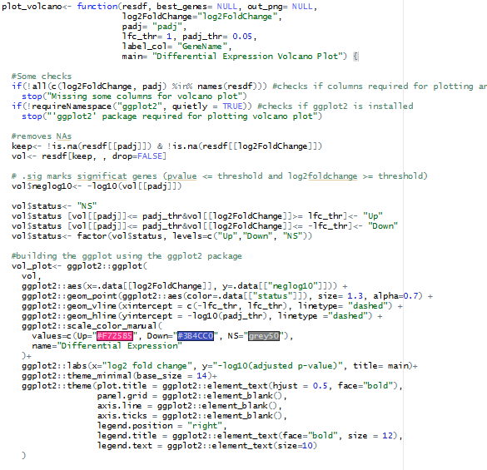
- Generating Volcano Plot

This function generates a volcano plot from the DESeq results dataframe. This function visualizes the relationship between log2fold change and statistical significance(log10 padj), helping to identify genes that are both highly differentially expressed and statistically significant. I began by adding checks to ensure that the necessary columns, log2FoldChange and padj, are present in the input dataframe, since these values are required for plotting. I also included a check to verify that the ggplot2 package is installed before proceeding, as it is essential for generating the plot. Before plotting, I filtered out any missing values in the relevant columns to prevent errors. I then defined thresholds for both the adjusted p-value and log2 fold change, which are used to classify genes as significant. Genes meeting these criteria are highlighted on the plot, making them easy to distinguish from non-significant ones. The function uses ggplot2 to create the volcano plot, displaying log2 fold change on the x-axis and the negative log10 of the adjusted p-value on the y-axis, with horizontal and vertical lines marking the chosen significance thresholds.
Suppose a list of top genes (from the previous top_genes function) is provided. In that case, the function adds text labels to those specific genes on the plot using ggrepel, which prevents overlapping labels and keeps the visualization clear. Finally, the function saves the volcano plot as a PNG.

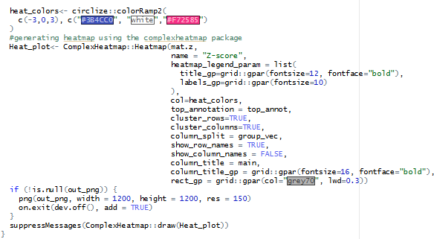
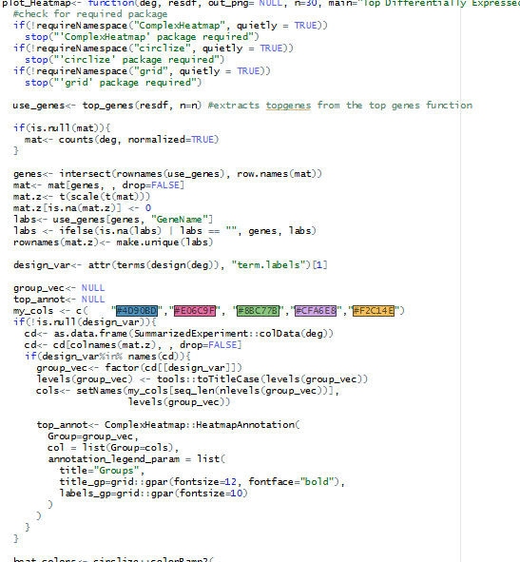
- Generating HeatMap

In this step, I created a function to generate a heatmap visualization of the top differentially expressed genes. The function uses the ComplexHeatmap package, so I included a check to ensure that the package is installed before running. The function begins by identifying the top genes from the results dataframe using the top_genes() function, where the number of genes to display (n) can be adjusted as needed.
Next, I extracted the normalized count values for those top genes from the DESeq dataset and scaled the data using z-scores to standardize expression values across samples. This normalization helps highlight patterns of relative expression rather than raw count differences. I then handled any missing values by replacing NAs with zeros and ensured that the gene names used as row labels were unique. If any gene names were missing, they were replaced with blank labels to avoid errors during plotting.
The heatmap itself is generated using the Heatmap() function from ComplexHeatmap, with both rows (genes) and columns (samples) clustered to reveal expression trends across experimental groups. The heatmap includes row and column names for clarity, and the column title is set using the main argument. If the out_png argument is specified, the heatmap is saved as a high-resolution PNG file.

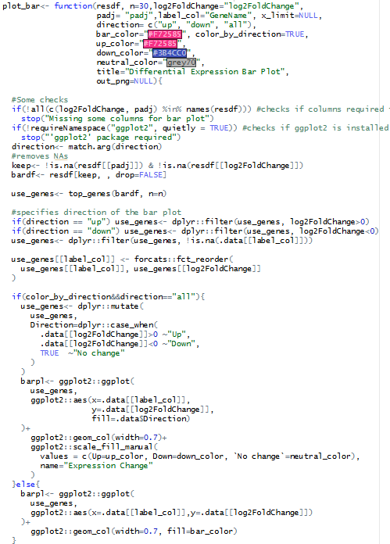
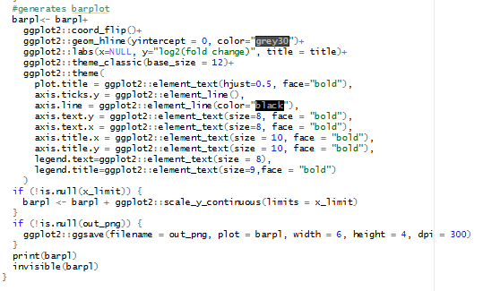
- Generating BarPlot

For this step, I created a function to visualize the log2 fold changes of the top differentially expressed genes as a bar plot. This function allows the user to display either upregulated, downregulated, or all significant genes, depending on the direction argument. It begins by checking that the required columns (log2FoldChange and padj) are present in the results dataframe and that the ggplot2 package is installed, since it’s needed for generating the plot. The function also removes any missing values in these columns to avoid plotting errors.
After validation, the top genes are extracted using the top_genes() function. Depending on the user’s input, the function filters genes with positive log2 fold change values (for upregulated genes) or negative ones (for downregulated genes). The gene labels are then reordered according to their fold change values using the forcats package to ensure they appear in a clear, sorted order on the plot.
The bar plot is generated using ggplot2, with genes on the y-axis and their log2 fold changes on the x-axis. Each bar represents a gene, and a horizontal line is drawn at zero to visually separate upregulated and downregulated genes. Bar color can be changed through the bar_color argument. If the out_png argument is provided, the plot is saved as a high-resolution PNG file.

FINAL PROJECT (R SHINY APP)
- UI Fluid Page Layout
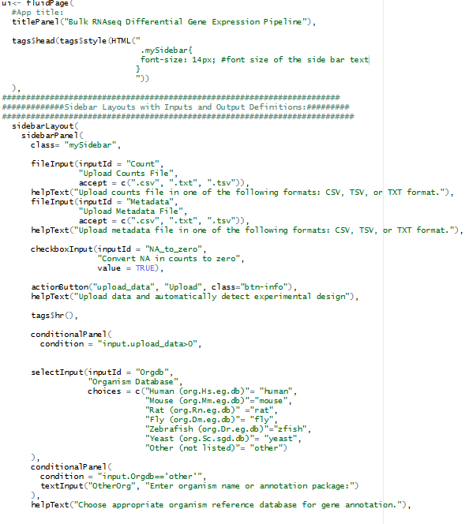

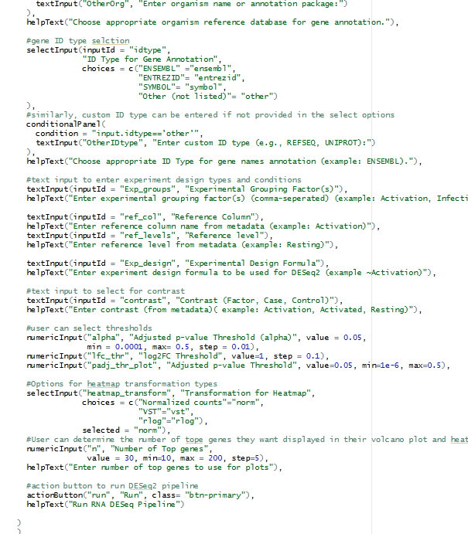

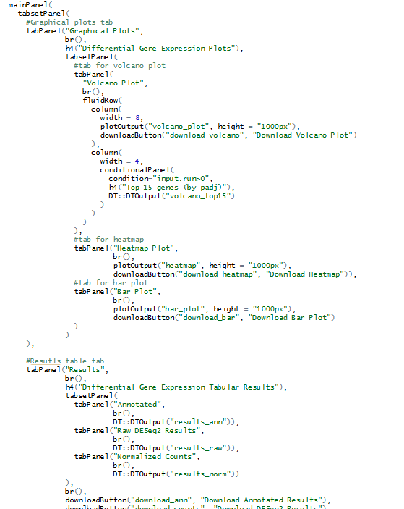
There are two parts of a shiny app: the UI and the server. In my UI, I used a sidebarLayout, which divides the page into a side panel (for inputs) and a main panel (for outputs). I first added the titlePanel() to display the title “Bulk RNAseq Differential Gene Expression Pipeline” at the top of the page. I also adjusted the font size of my sidebar using the tag$head() to make it more readable.
Next, I set up the side bar section using sidebarPanel(), where I entered different input types, including fileInput() (to upload count and metadata), helpText() to explain to the user what they need to enter, checkboxInput() for the NA to zero option, and “Upload”_action button to upload data. Only after the upload button is clicked do users see the remaining inputs needed to run the pipeline. These additional inputs include text inputs for entering different experimental design options and reference levels, as well as numeric inputs for entering significance threshold levels. At the bottom of the sidebar, I added a “Run” button to run the pipeline.
In the main panel, outputs are organized into two tabs and sub-tabs within each tab. The first tab contains graphical plots, with subtabs for different types of plots (volcano, bar, and heatmap). I used plotOutput() to render the corresponding plots at a fixed height of 1000px, and there is also a download button at the bottom for users to download the plots if they choose. In the volcano plot tab, I added a table of the top 15 genes using DT::DTOutput(). The second main tab in the main panel is the results tab, which contains tabs for various results such as annotated results, raw DESeq2 output, and normalized data.

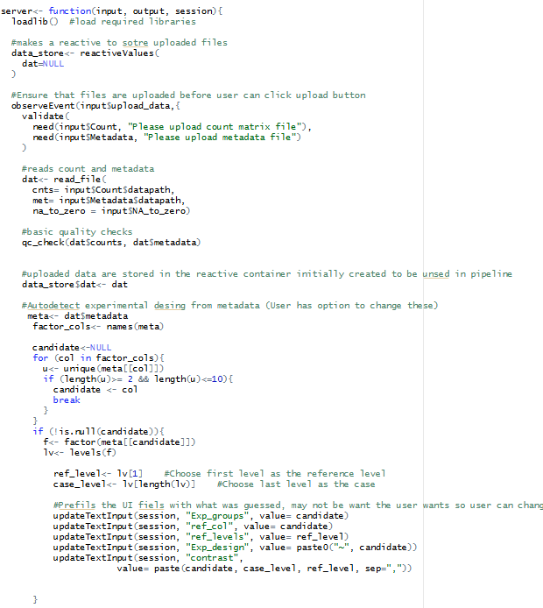
- Defining the Server and Running The Shiny App

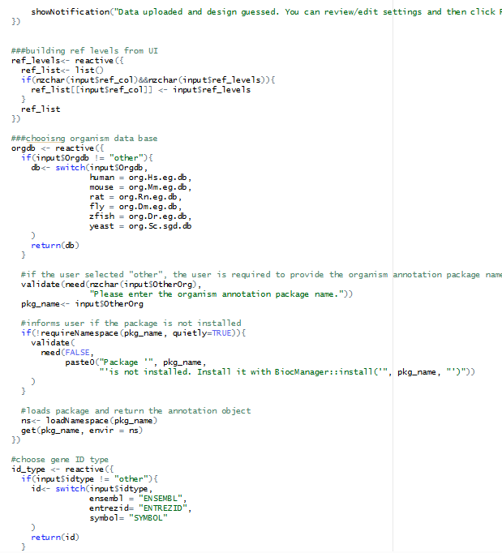

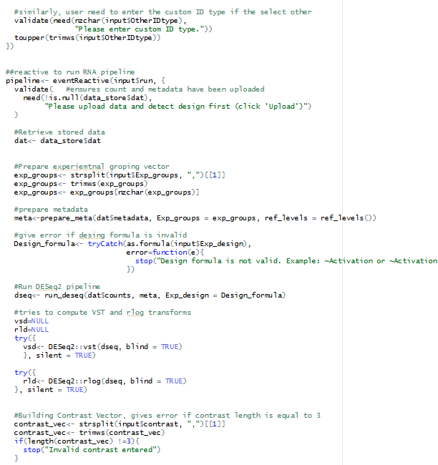

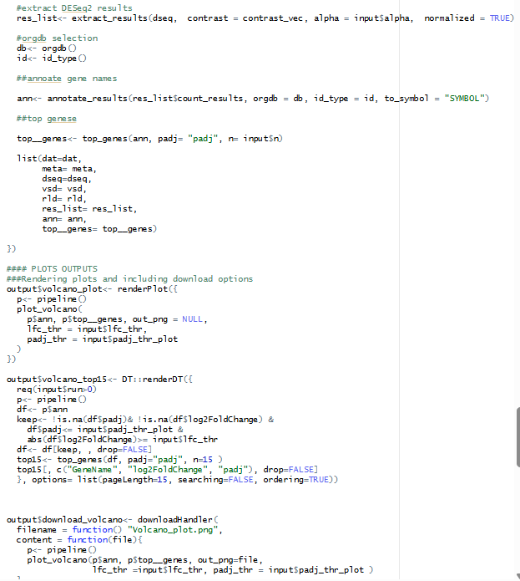

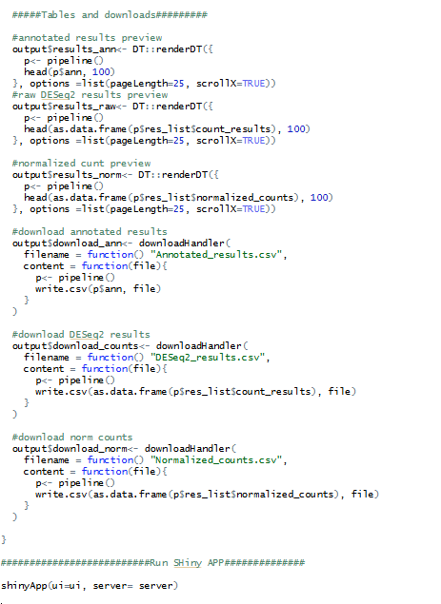
In the server(), I first used observeEvent() to react to the user clicking the upload button. This ensures that both count and metadata have been uploaded and run the quality checks. The data are stored in a reactiveValues() object that will be reused later. I then tried to guess the experimental conditions (exp_groups, ref level, etc.); if one is found, it is prefilled in the UI text inputs (grouping factor, reference column/level, design formula, and contrast), and the user is notified that the experiment design has been guessed (NOTE: the user is free to change the inputs before running the pipeline).
Next, I defined reactive expressions for reference levels, organism database, and geneID type. These handle the given choices as well as user-specified options and check that annotation packages are already installed. The RNA-seq analysis (pipeline <- eventReactive()) is conducted when the user clicks the Run button. Inside, I ensure data is uploaded, prepare the metadata, build the design formula, run DESeq2, compute VST/rlog transforms, extract differential expression results, annotate genes, and select top genes. All these steps use the functions I developed in the midterm project. The results are returned as a list and used across different outputs.
In the plotting section, I use renderPlot() to create the volcano plot, heatmap, and bar plot from the pipeline results. Each plot has its corresponding downloadHandler() so users can save plots as PNG files in their chosen folder. The volcano plot displays the top 15 significant genes as a table using DT::renderDT().
Lastly, I generated result tables for the annotated results, raw DESeq2, and normalized counts, showing the first 100 rows for display. Similarly, users can download these full tables as CSV files to their desired locations. Then I run the shiny App: shinyApp(ui=ui, server=server).
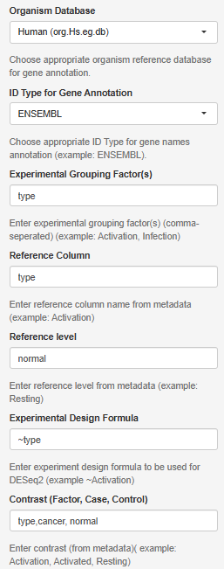
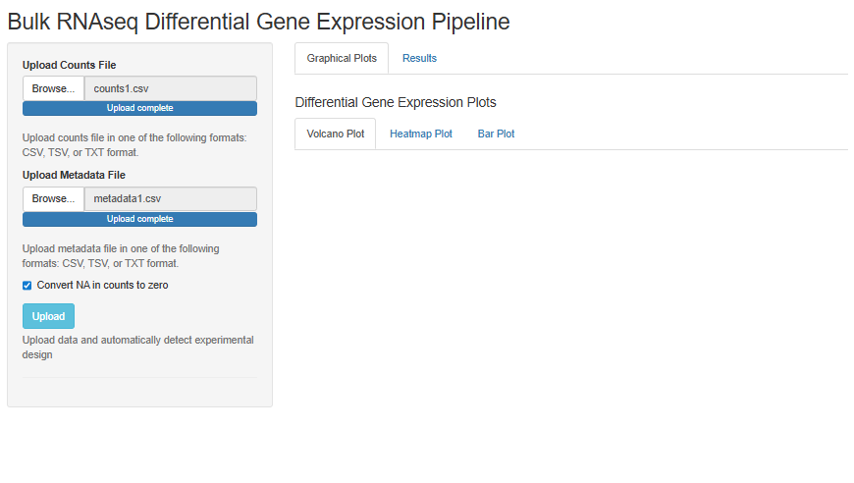
- How to Use the App

Files uploaded, and action button (Upload) clicked next.
Experiment conditions were prefiled, but I changed some values like Reference level from cancer to normal and then the contrast from type, normal, cancer to type, cancer, normal.

The default number of top genes is 30, but I changed it to 50.

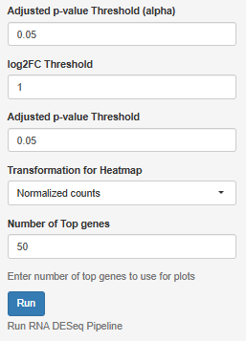

- Example of Results:
